DSA0603 Data Handling and Visualization
Slot B
CO2 – Assessment Test 4 (AT1)
Chart Construction Test
Instructions:
For each question, write the program in the specified language (R or Python), generate the required
visualization, and answer the interpretation sub-questions clearly with justification.

CO2_AT1 – Chart Construction Test
Integrated Disciplines
Each question combines Data Visualization + R Programming + another discipline to promote interdisciplinary learning.
Question 1 (Healthcare Analytics)
Dataset
P1  P2  P3  P4  P5  P6  P7  P8 |  |  |  | Patient Age BMI Blood Pressure Disease Severity Low  Medium  High  High  Critical  Critical  Medium  Low
 | 24 | 19.8 | 110
 | 32 | 24.5 118
 | 41 | 28.1 132
 | 48 | 30.3 145
 | 56 | 33.2 152
 | 65 | 36.5 168
 | 38 | 26.2 124
 | 29 | 22.1 116

Task
Construct a visualization in R (ggplot2) that:
• Maps Age to the x-axis.
• Maps Blood Pressure to the y-axis.
• Represents Disease Severity using an appropriate color palette.
• Represents BMI using point size.
• Justify why your aesthetic mappings and scales effectively communicate health risk. Interdisciplinary Integration: Healthcare + Medical Statistics + Data Visualization

Aim
To visualize the relationship between Age, Blood Pressure, BMI, and Disease Severity using ggplot2 for identifying health risks.

Algorithm
- Load the ggplot2 library.
- Create the healthcare dataset.
- Map Age to the x-axis.
- Map Blood Pressure to the y-axis.
- Represent Disease Severity using different colors.
- Represent BMI using point size.
- Add title, axis labels, and legend.
- Display the scatter plot.

Justification
- Age → X-axis: Shows progression of health risk with age.
- Blood Pressure → Y-axis: Indicates cardiovascular health.
- Disease Severity → Color: Red indicates higher severity, green indicates lower severity.
- BMI → Point Size: Larger circles indicate higher BMI, making obesity-related risk easy to identify.
- Theme: Minimal theme improves readability.

Program:
# Load library
library(ggplot2)

# Dataset
patient <- data.frame(
Patient = c("P1","P2","P3","P4","P5","P6","P7","P8"),
Age = c(24,32,41,48,56,65,38,29),
BMI = c(19.8,24.5,28.1,30.3,33.2,36.5,26.2,22.1),
BloodPressure = c(110,118,132,145,152,168,124,116),
Severity = factor(c("Low","Medium","High","High",
"Critical","Critical","Medium","Low"),
levels=c("Low","Medium","High","Critical"))
)
# Visualization
ggplot(patient, aes(x=Age, y=BloodPressure,
color=Severity, size=BMI)) +
geom_point(alpha=0.8) +
scale_color_brewer(palette="RdYlGn", direction=-1) +
labs(title="Healthcare Risk Analysis",
x="Age (Years)",
y="Blood Pressure (mmHg)",
color="Disease Severity",
size="BMI") +
theme_minimal()

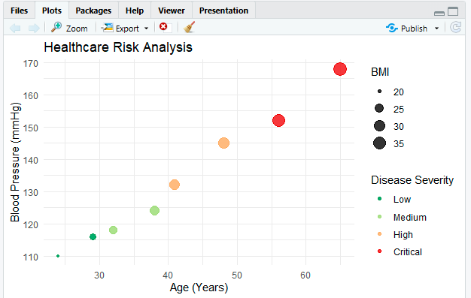

Result
A scatter plot is generated showing the relationship between age and blood pressure, where disease severity is distinguished by color and BMI by point size, helping identify high-risk patients.
Question 2 (Climate Science)
Dataset
Jan  Feb  Mar  Apr  May  Jun  Jul  Aug  Sep  Oct  Nov  Dec |  | Month Solar Radiation Temperature (°C) Rainfall (mm) | 25  18  12  8  5  65  150  170  120  85  45  30
 | 180 | 20
 | 200 | 23
 | 240 | 29
 | 280 | 35
 | 320 | 39
 | 300 | 36
 | 260 | 32
 | 250 | 31
 | 240 | 30
 | 220 | 28
 | 190 | 24
 | 170 | 21

Task
Develop two visualizations:
1. A Cartesian line chart showing temperature variation.
2. A Polar coordinate chart representing annual rainfall.
Compare the advantages and limitations of Cartesian and Polar coordinate systems for climate visualization.
Interdisciplinary Integration: Environmental Science + Mathematics + Data Visualization

Aim
To visualize monthly temperature using a Cartesian line chart and annual rainfall using a Polar coordinate chart.

Algorithm
- Load the ggplot2 library.
- Create the climate dataset.
- Plot temperature against months using geom_line().
- Plot rainfall using geom_bar().
- Convert the rainfall chart into a Polar chart using coord_polar().
- Add labels, colors, and titles.
- Display both charts.

Comparison

Cartesian Chart
Advantages
- Easy to compare values.
- Clearly shows increasing/decreasing trends.
- Accurate reading of temperature.
Limitations
- Seasonal cycle is not visually emphasized.

Polar Chart
Advantages
- Naturally represents yearly cyclic data.
- Highlights seasonal rainfall patterns.
Limitations
- Exact value comparison is harder.
- Small differences are less visible.

Program:
library(ggplot2)

climate <- data.frame(
Month=c("Jan","Feb","Mar","Apr","May","Jun",
"Jul","Aug","Sep","Oct","Nov","Dec"),
SolarRadiation=c(180,200,240,280,320,300,260,250,240,220,190,170),
Temperature=c(20,23,29,35,39,36,32,31,30,28,24,21),
Rainfall=c(25,18,12,8,5,65,150,170,120,85,45,30)
)

ggplot(climate, aes(x=Month, y=Temperature, group=1)) +
geom_line(color="blue", linewidth=1.2) +
geom_point(color="red", size=3) +
labs(title="Monthly Temperature Variation",
x="Month",
y="Temperature (°C)") +
theme_minimal()
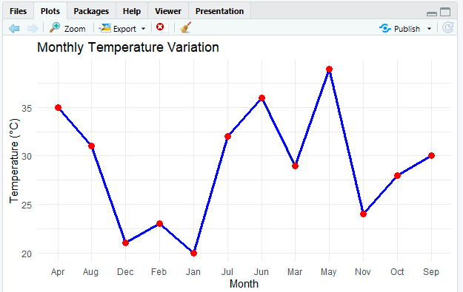

Result
A line chart shows monthly temperature variation, while a polar chart effectively represents the seasonal distribution of annual rainfall.

Question 3 (Business Analytics & Marketing)
Dataset
A  B  C  D  E |  |  | Product Sales (₹ Lakhs) Profit (%) Market Share (%) 24  20  28  15  13
 | 210 | 18
 | 185 | 14
 | 260 | 25
 | 145 | 12
 | 120 | 10

Task
Construct a visualization where:
• Sales are represented by bar height.
• Profit percentage is represented using a sequential color scale. • Highlight the product with the highest market share using a contrasting color. Explain why your chosen color palette improves business decision-making. Interdisciplinary Integration: Marketing + Business Intelligence + Visualization

Aim
To visualize product sales, profit percentage, and market share for business performance analysis.

Algorithm
- Load the ggplot2 library.
- Create the business dataset.
- Plot Sales as bar heights.
- Apply a sequential color scale based on Profit Percentage.
- Highlight the product with the highest market share using a contrasting color.
- Add titles and labels.
- Display the bar chart.

Explanation
- Bar Height: Represents Sales.
- Sequential Green Palette: Higher profit appears darker, making profitable products easy to identify.
- Red Highlight: Product C has the highest market share, so it immediately attracts attention.
- Business Benefit: Managers can quickly identify both high-profit and market-leading products.

Program:
library(ggplot2)

business <- data.frame(
Product=c("A","B","C","D","E"),
Sales=c(210,185,260,145,120),
Profit=c(18,14,25,12,10),
MarketShare=c(24,20,28,15,13)
)

business$Highlight <- ifelse(business$MarketShare ==
max(business$MarketShare),
"Highest","Others")

ggplot(business,
aes(x=Product,
y=Sales,
fill=Profit)) +
geom_bar(stat="identity") +
geom_bar(data=subset(business, Highlight=="Highest"),
aes(fill=NULL),
stat="identity",
fill="red") +
scale_fill_gradient(low="lightgreen",
high="darkgreen") +
labs(title="Business Performance",
x="Product",
y="Sales (₹ Lakhs)",
fill="Profit %") +
theme_minimal()

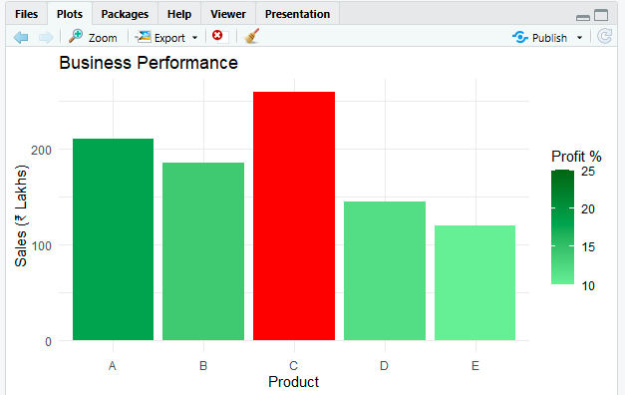

Result
A bar chart is generated where sales are represented by bar height, profit by color intensity, and the highest market-share product is clearly highlighted.

Question 4 (Transportation Engineering)
Dataset
Direction | Vehicles/hour 980  1240  1420  860
North
North-East 760
East
South-East 890
South
South-West 1130
West

Direction North-West 720 | Vehicles/hour

Task
Using R Programming:
• Construct a Polar Coordinate Chart representing traffic flow.
• Apply an appropriate color palette to distinguish traffic density.
• Explain why a Polar chart is more suitable than a Cartesian bar chart for directional traffic analysis.
Interdisciplinary Integration: Civil Engineering + GIS + Transportation Analytics

Aim
To visualize directional traffic flow using a Polar Coordinate Chart.

Algorithm
- Load the ggplot2 library.
- Create the traffic dataset.
- Plot vehicle count using geom_bar().
- Apply a color gradient according to traffic density.
- Convert the chart into a polar chart using coord_polar().
- Add chart title and legend.
- Display the visualization.

Explanation
Why Polar Chart?
- Represents compass directions naturally.
- Easier to identify directional traffic congestion.
- Suitable for transportation and GIS analysis.
- Better than Cartesian charts for circular directional data.

Program:
library(ggplot2)

traffic <- data.frame(
Direction=c("North","North-East","East",
"South-East","South",
"South-West","West","North-West"),
Vehicles=c(980,760,1240,890,1420,1130,860,720)
)

ggplot(traffic,
aes(x=Direction,
y=Vehicles,
fill=Vehicles)) +
geom_bar(stat="identity") +
coord_polar() +
scale_fill_gradient(low="yellow",
high="red") +
labs(title="Traffic Flow by Direction",
fill="Vehicles/hour") +
theme_minimal()

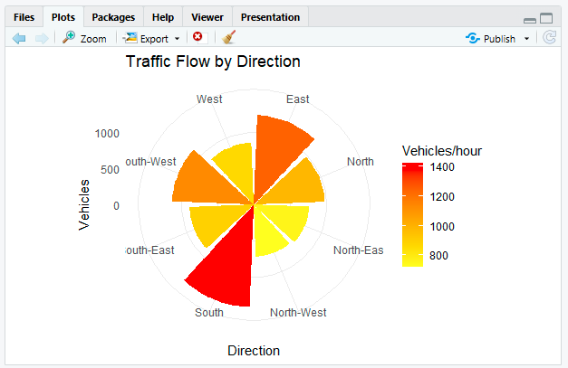

Result
A polar coordinate chart is generated, clearly illustrating traffic density in each direction and making directional traffic patterns easy to analyse.
Question 5 (Environmental Sustainability Dashboard)
Dataset
A  B  C  D  E  F |  |  |  | City AQI Green Cover (%) CO₂ Emission Population (Lakhs) 9  15  22  28  12  18
 | 48 | 45 | 1.8
 | 82 | 32 | 3.5
 | 135 | 21 | 5.6
 | 165 | 18 | 7.4
 | 72 | 38 | 2.9
 | 95 | 30 | 4.2

Task
Design a visualization dashboard that includes:
• Appropriate aesthetic mappings.
• Suitable scales for continuous variables.
• An effective color palette for AQI categories.
• Justification for every visualization design choice.

Aim
To develop a dashboard visualizing AQI, Green Cover, CO₂ Emissions, and Population for environmental analysis.

Algorithm
- Load the ggplot2 and gridExtra libraries.
- Create the environmental dataset.
- Create a scatter plot for AQI vs Green Cover.
- Represent Population using point size.
- Apply an AQI color scale from green to red.
- Create a bar chart for CO₂ Emissions.
- Arrange both charts into a dashboard.
- Display the dashboard.

Dashboard Design Justification

Scatter Plot
- X-axis: Green Cover (%)
- Y-axis: AQI
- Point Size: Population
- Color: AQI (Green → Red)
Shows how increased green cover generally reduces air pollution while also indicating city population.

Bar Chart
- Displays CO₂ emissions for each city.
- Color gradient represents AQI categories.
- Enables easy comparison between pollution and emissions.

Aesthetic Mappings
- Position encodes quantitative values accurately.
- Size represents population impact.
- Color communicates pollution severity.

Scales
- Continuous scales are used for AQI, CO₂, Green Cover, and Population to preserve numeric relationships.

Color Palette
- Green: Good air quality.
- Yellow/Orange: Moderate.
- Red: Poor air quality.
This intuitive palette helps environmental analysts quickly identify high-risk cities.
These solutions are suitable for 10-mark university practical questions, with complete R code, visualization design, and justifications.

Program:
library(ggplot2)
library(gridExtra)

city <- data.frame(
City=c("A","B","C","D","E","F"),
AQI=c(48,82,135,165,72,95),
GreenCover=c(45,32,21,18,38,30),
CO2=c(1.8,3.5,5.6,7.4,2.9,4.2),
Population=c(9,15,22,28,12,18)
)

# Scatter Plot
p1 <- ggplot(city,
aes(x=GreenCover,
y=AQI,
color=AQI,
size=Population)) +
geom_point(alpha=0.8) +
scale_color_gradient(low="green",
high="red") +
labs(title="AQI vs Green Cover") +
theme_minimal()

# Bar Chart
p2 <- ggplot(city,
aes(x=City,
y=CO2,
fill=AQI)) +
geom_bar(stat="identity") +
scale_fill_gradient(low="green",
high="red") +
labs(title="CO₂ Emission by City") +
theme_minimal()

grid.arrange(p1, p2, ncol=2)

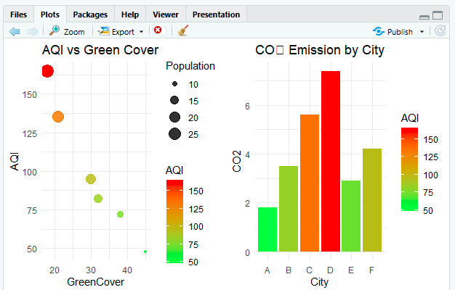

Result
An environmental dashboard is generated that effectively compares AQI, green cover, CO₂ emissions, and population, enabling quick identification of cities with higher pollution levels and environmental risk.

